CSBG Performance Management Website
Training/Practice Exercises

ANSWER KEY

Table of Contents
Practice Exercise #1 2
EXERCISES 2
SOLUTIONS 3
WADE IN SOLUTION 3
JUMP IN SOLUTION 6
DEEPER DIVE SOLUTION 9

Practice Exercise #1

EXERCISES

WADE IN: You are preparing for a statewide meeting with your CSBG entities and would like to present a graph showing your state’s progress toward meeting organizational standards in FY 2019. Using the CSBG Quick Facts option, how would you generate this report?
JUMP IN: To provide more context, you decide to look at your state’s progress toward meeting Organizational Standards over time. Using the Customize option at the top of the report screen, how would you revise your existing report (above) to add in FY 2018 data?
DEEPER DIVE: You decide it would be valuable to show entities how your state’s progress in meeting CSBG Organizational Standards compares to national progress. How would you add national data to your existing graph/table using the Customize option at the top of the report screen?

SOLUTIONS

WADE IN SOLUTION: You are preparing for a statewide meeting with your CSBG entities and would like to present a graph showing your state’s progress toward meeting organizational standards in FY 2019. Using the CSBG Quick Facts option, how would you generate this report?

STEP 1: Once in the Data Warehouse, select the CSBG Quick Facts icon.

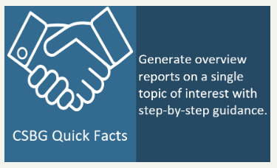

STEP 2: In the Quick Facts screen, select Single State Reports (since we are only interested in looking at one state).
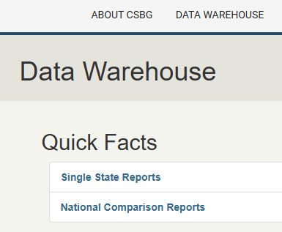

STEP 3: In the Single State Reports screen, select “What percentage of CSBG eligible entities are meeting Organizational Standards?” Then, select Next.

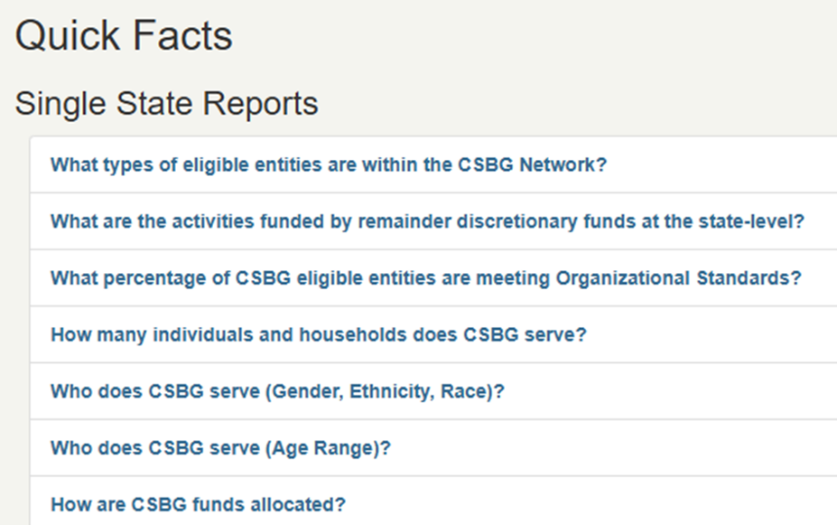

STEP 4: On the State Selection screen, select your state. (In the example, we are using New Mexico, but feel free to use any state.) Then, select next.
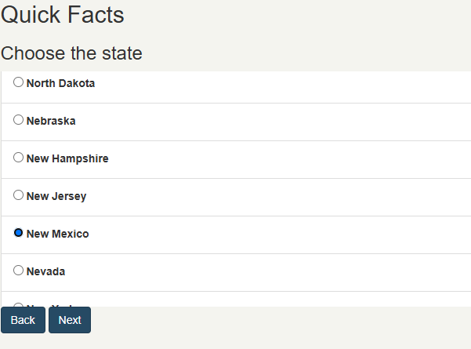

STEP 5: On the Year Selection screen, select “2020.” Then, select Next.
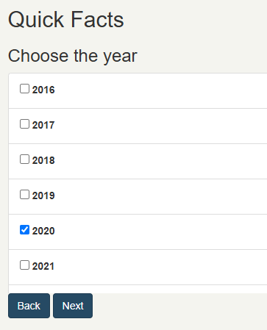

RESULT: We can now see a bar graph titled “Organizational Standards Snapshots.”
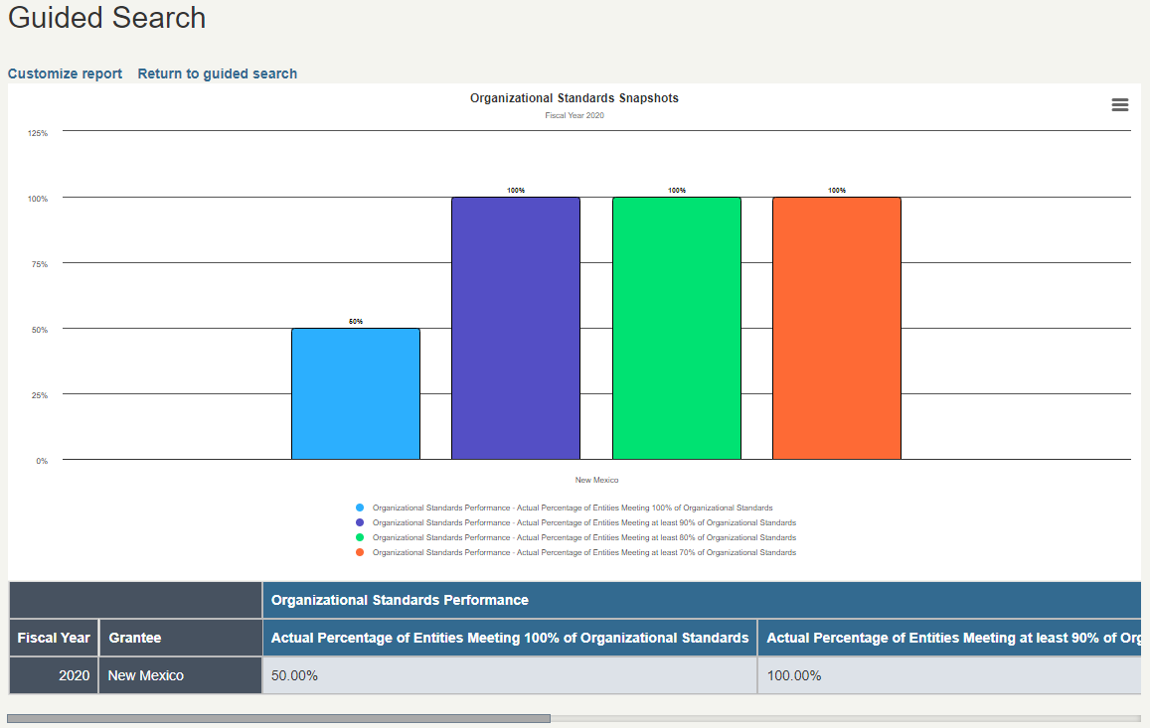

JUMP IN SOLUTION: To provide more context, you decide to look at your state’s progress toward meeting Organizational Standards over time. Using the Customize option at the top of the report screen, how would you revise your existing report (above) to add in FY 2018 data?
STEP 1: Starting on the results page from the previous example, click “Customize report” at the top of the page.

STEP 2: Under Step 1 of the customize screen, some criteria will already be selected from our previous report—including the year (2020), the geography (State Data) and state. Click on “2019” to add that additional data to the report.

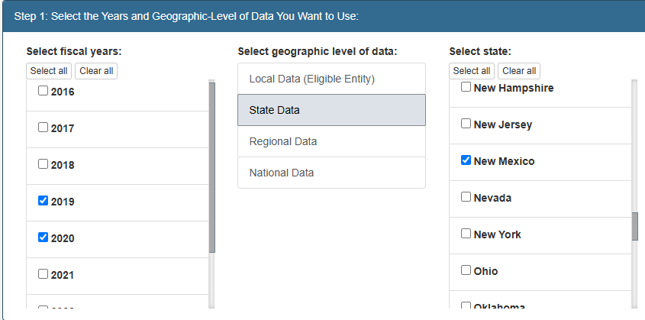

STEP 3: Under step 2 of the customize screen, our selections from the previous report are already selected, so we do not have to make any changes to this step.
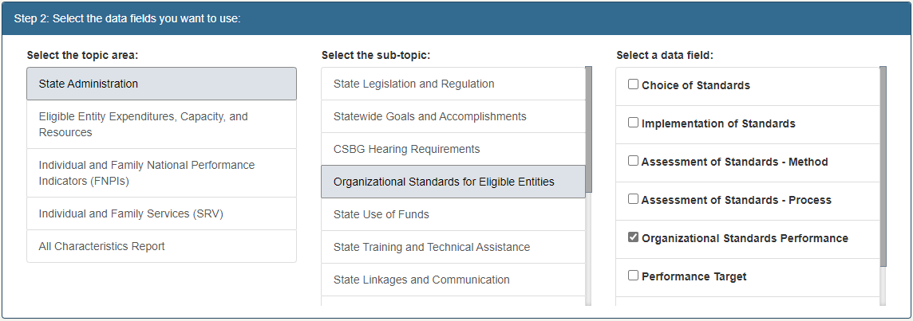

For this exercise, you can skip Step 3 of the customization.

STEP 4: Under Step 4, we want to make sure that “Bar graph” remains selected as the option for displaying the data.
Under “Add a title, subtitle, and description,” you may choose to update the subtitle to add “2019”, so that anyone viewing this report later will know that both years are included. Once that is complete, we’ll click “Create Data Report.”
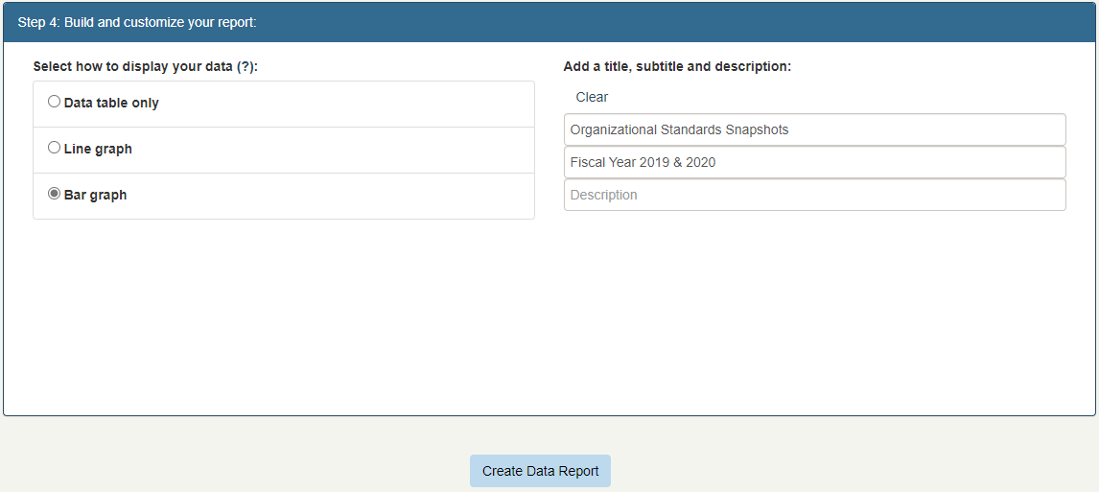

RESULT: We can now see a bar graph that shows the FY 2019 and 2020 data.
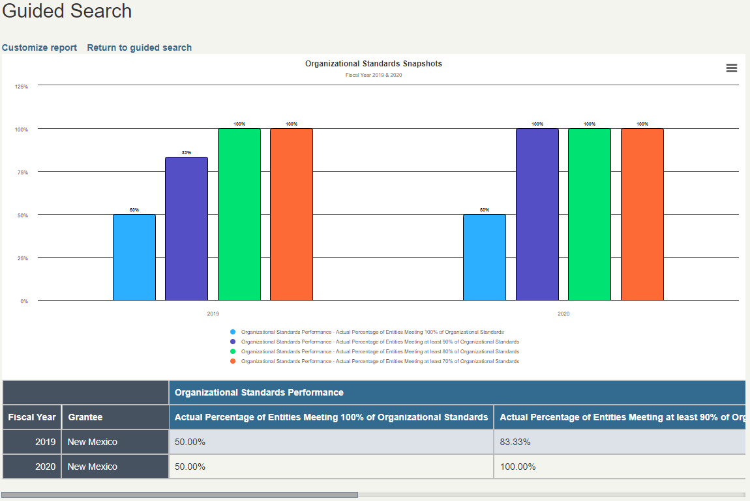

DEEPER DIVE SOLUTION: You decide it would be valuable to show entities how your state’s progress in meeting CSBG Organizational Standards compares to national progress. How would you add national data to your existing graph/table using the Customize option at the top of the report screen?
STEP 1: Starting on the results page from the previous example, click “Customize report” at the top of the page.

STEP 2: Under Step 1 of the customize screen, some criteria will already be selected from our previous report—including the years (2019 and 2020), the geography (State Data) and the state. Click on “National Data” and “United States” to add that additional data to the report.
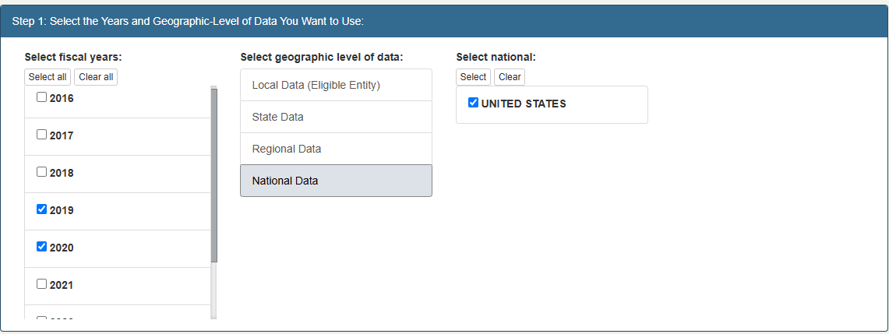

For this exercise, you can skip Steps 2 and 3 of the customization screen.

Step 3: In the last section, we want to make sure that “Bar graph” remains selected as the option for displaying the data.

Under “Add a title, subtitle, and description,” you may choose to update the title to add “National Comparison”, so that anyone viewing this report later will know that the national values are included. Once that is complete, we’ll click “Create Data Report.”
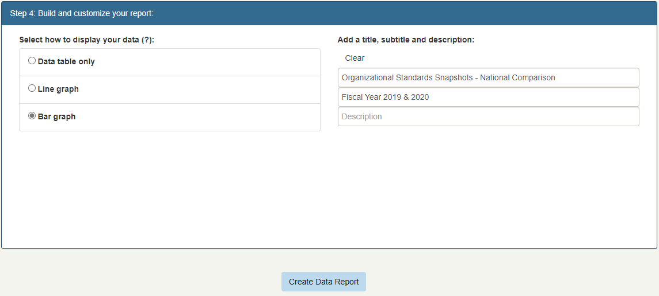

RESULT: If you completed the steps correctly, you should see a bar graph that shows the 2019 and 2020 data compared to the national results.
